**Interactive Multimedia Programming**

1. Assignment set

1 – RWD

Get a beautiful website, which can adapt itself on mobile screen.

The most part of web consultation is on a mobile phone now.

2 – RWD exemple

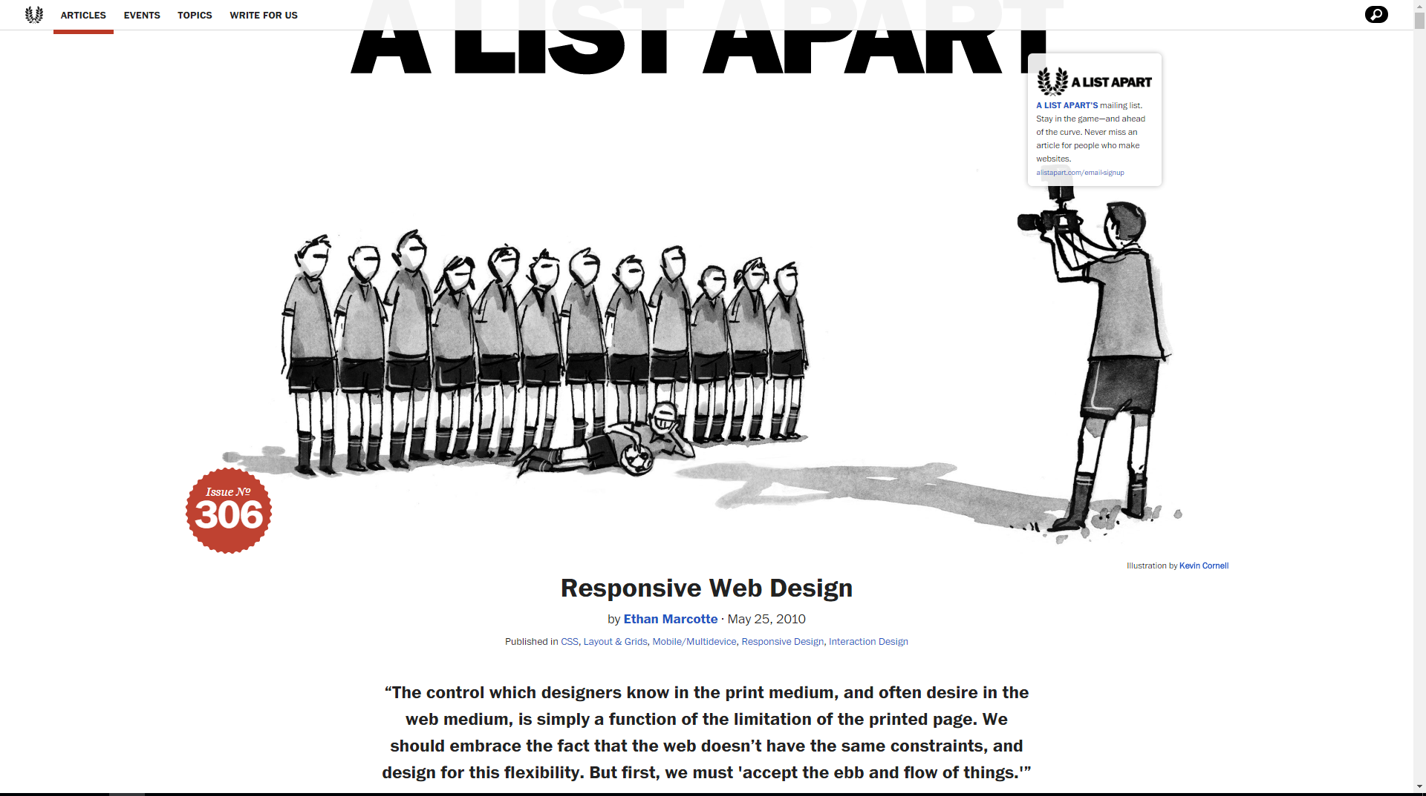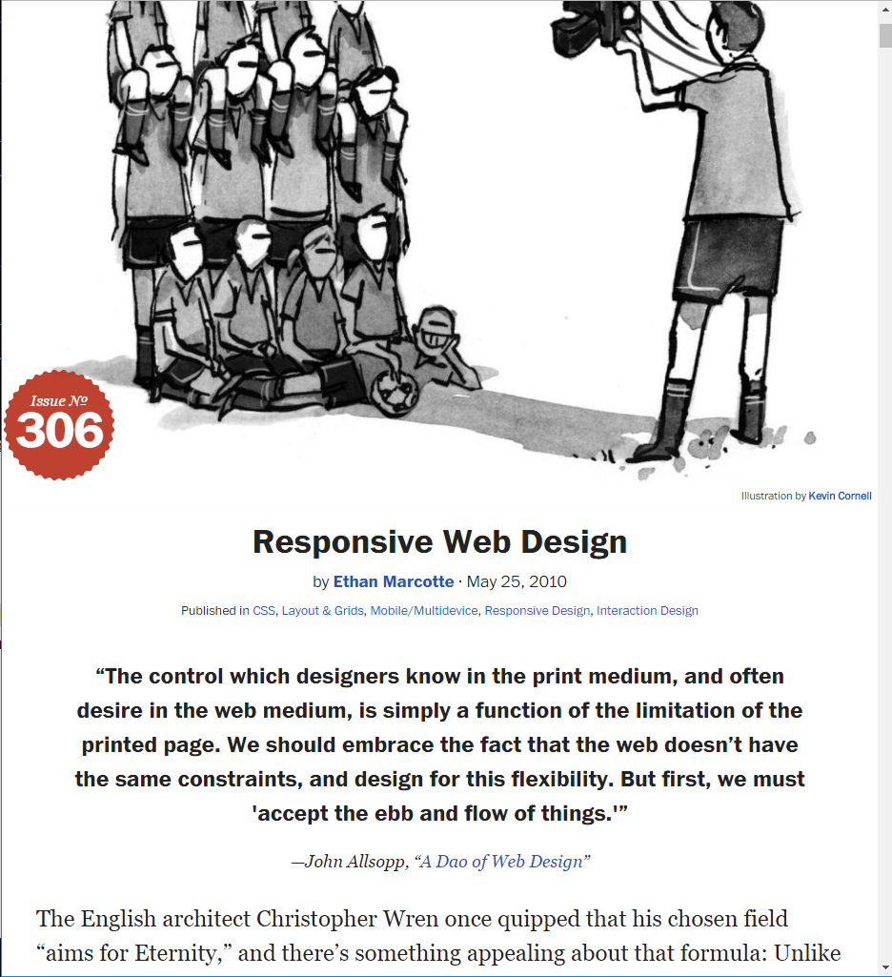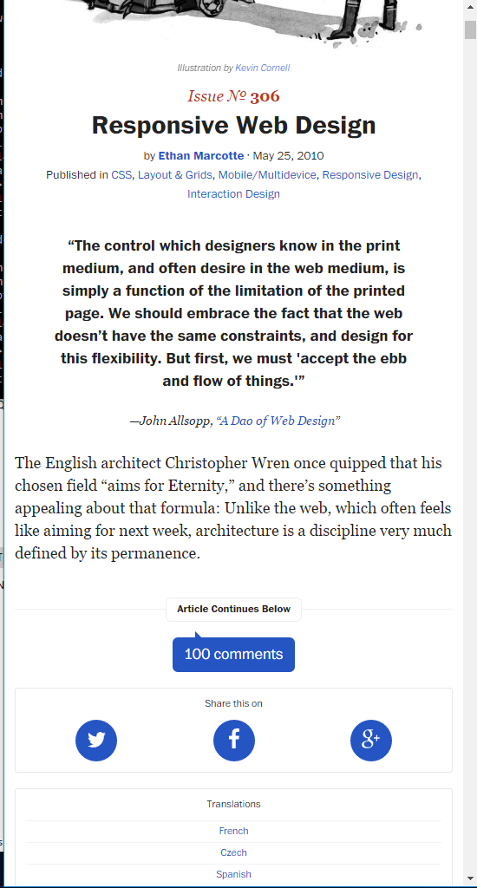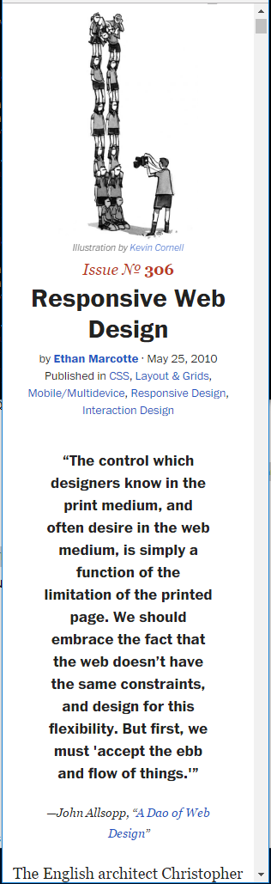

3 – RWD in practice